EXPT NO:2 | Implementation of data visualization techniques
DATE: 06.01.2026 | Implementation of data visualization techniques

PRE-LAB QUESTIONS (PROVIDE BRIEF ANSWERS TO THE FOLLOWING QUESTIONS)
- Why is exploratory data analysis critical before model building?
It helps understand data patterns, quality, and relationships before modeling.
- How do distributions influence algorithm selection in ML?
Different algorithms perform better depending on data symmetry and skewness.
- What insights can outliers provide in business data?
They may indicate fraud, rare events, or high-value customers.
- Why are visual summaries preferred over raw tables?
They make trends and anomalies easier to identify quickly.
- How does visualization improve business intelligence?
It enables faster and more informed decision making.

IN-LAB EXERCISE:
OBJECTIVE:

To explore data distribution and variability using advanced visualization techniques.
SCENARIO:
A startup analyzes e-commerce transaction data to understand customer spending behavior and detect abnormal purchase patterns.

IN-LAB TASKS (Using R Language)
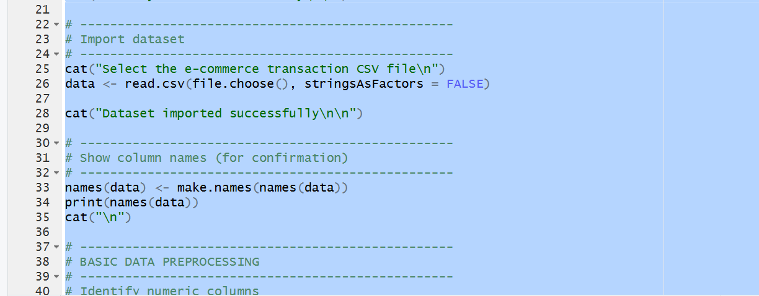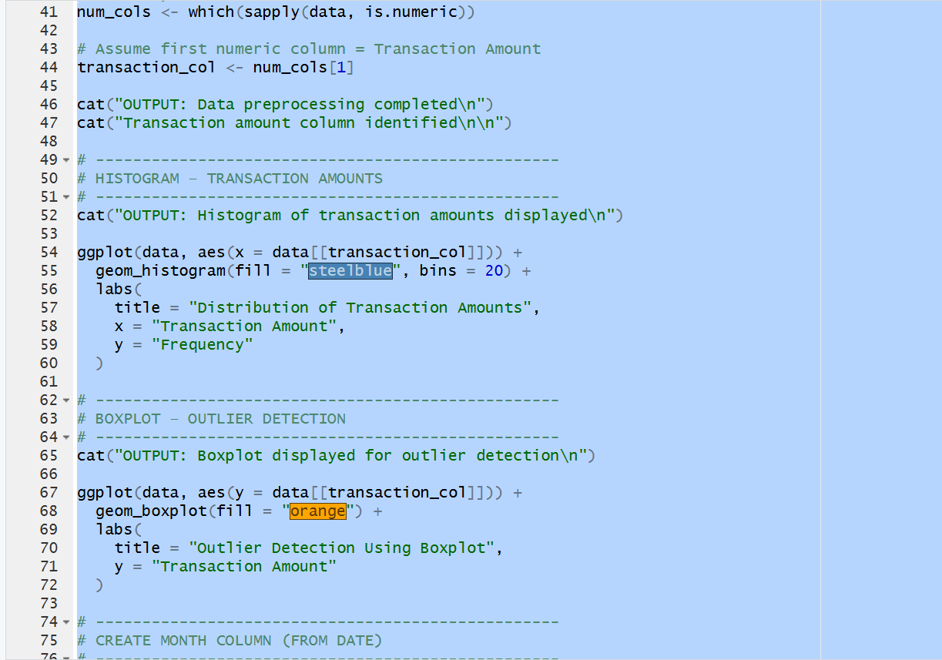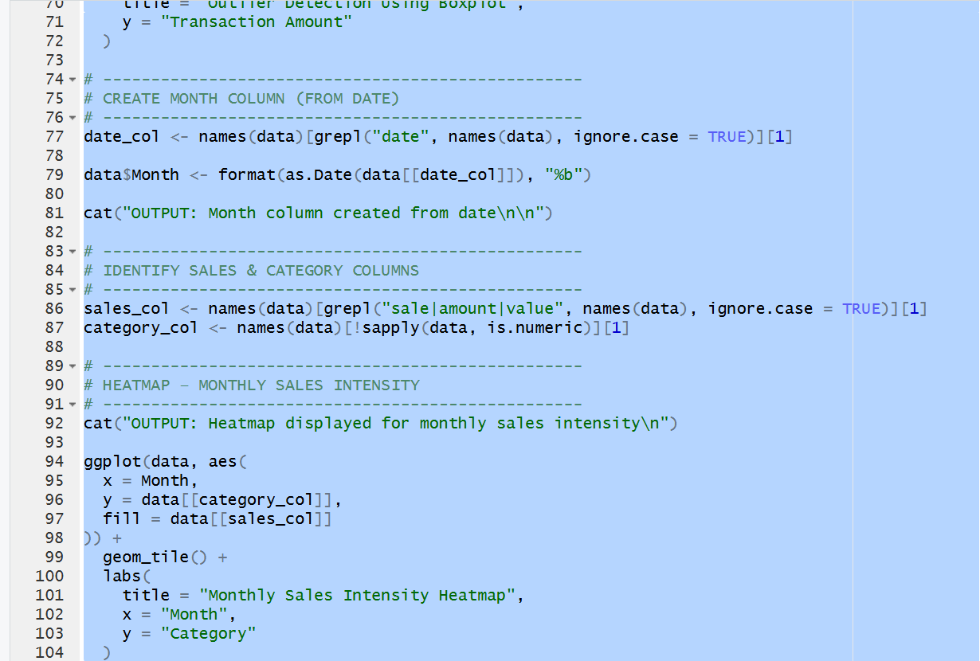

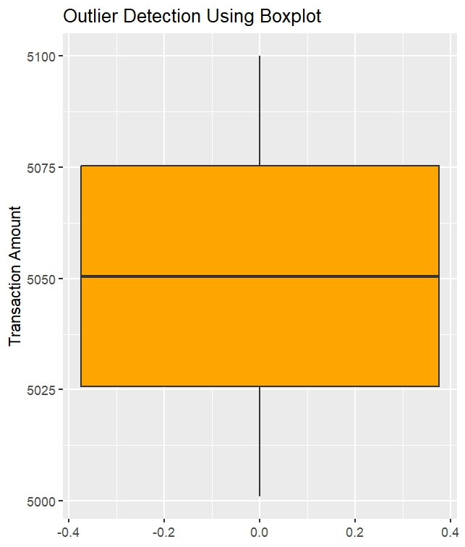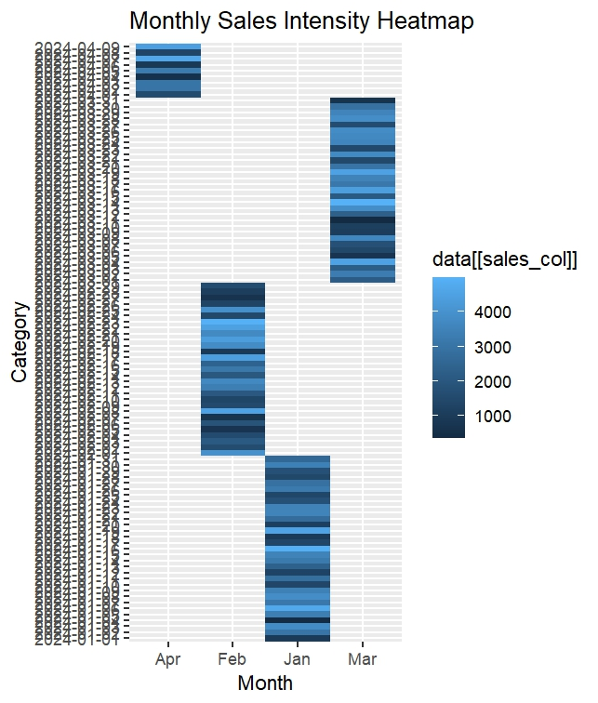
(CODE: CONATAINS STUDENT ROLL NOS
SCREENSHOT OF CODE
SCREENSHOT OF OUTPUT)

POST-LAB QUESTIONS (PROVIDE BRIEF ANSWERS TO THE FOLLOWING QUESTIONS)
What does right-skewed distribution indicate about customer behavior?
Most customers spend small amounts, with few high spenders.
How can detected outliers impact business decisions?
They help identify fraud or premium customers.
Which visualization best supports anomaly detection?
Boxplot.
How does EDA improve AI model accuracy?
By removing noise and selecting meaningful features.
How can visualization guide feature engineering?
It reveals patterns useful for feature selection and transformation.
ASSESSMENT
Description | Max Marks | Marks Awarded
Pre Lab Exercise | 5
In Lab Exercise | 10
Post Lab Exercise | 5
Viva | 10
Total | 30
Faculty Signature

